Experiment 1 : Implement and demonstrate the FIND-S algorithm for finding the most specific hypothesis based on a given set of training data samples.
# Find-S Algorithm in Python
def find_s(examples):
# Step 1: Initialize hypothesis with the first positive example
for example in examples:
if example[-1] == "Yes":
hypothesis = example[:-1]
break
# Step 2: For each positive example, generalize hypothesis
for example in examples:
if example[-1] == "Yes":
for i in range(len(hypothesis)):
if hypothesis[i] != example[i]:
hypothesis[i] = "?"
return hypothesis
# Training data (EnjoySport Example)
data = [
['Sunny', 'Warm', 'Normal', 'Strong', 'Warm', 'Same', 'Yes'],
['Sunny', 'Warm', 'High', 'Strong', 'Warm', 'Same', 'Yes'],
['Rainy', 'Cold', 'High', 'Strong', 'Warm', 'Change', 'No']
]
final_hypothesis = find_s(data)
print("Most Specific Hypothesis:", final_hypothesis)

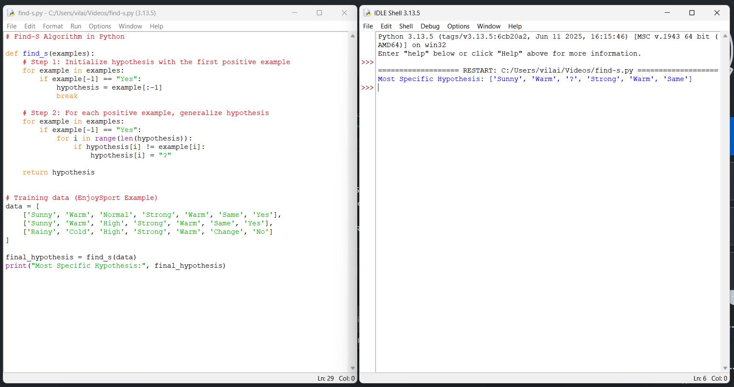
Experiment 2 : For a given set of training data examples stored in a .CSV file, implement and demonstrate the Candidate-Elimination algorithm in python to output a description of the set of all hypotheses consistent with the training examples
# Candidate Elimination Algorithm in Python
def more_general(h1, h2):
"""Check if hypothesis h1 is more general than h2"""
more_general_parts = []
for x, y in zip(h1, h2):
mg = x == "?" or (x != "?" and x == y)
more_general_parts.append(mg)
return all(more_general_parts)
def candidate_elimination(data):
# Initialize S as the first positive example
S = None
for row in data:
if row[-1] == "Yes":
S = row[:-1]
break
# Initialize G as most general hypothesis
G = [["?" for _ in range(len(S))]]
for row in data:
example, label = row[:-1], row[-1]
if label == "Yes":
# Remove from G any hypothesis inconsistent with example
G = [g for g in G if more_general(g, example)]
# Update S to be as specific as possible
for i in range(len(S)):
if S[i] != example[i]:
S[i] = "?"
else: # Negative example
# Remove S if it incorrectly classifies negative example
if more_general(S, example):
# Specialize G
new_G = []
for g in G:
for i in range(len(g)):
if g[i] == "?":
new_h = g.copy()
new_h[i] = S[i]
if not more_general(new_h, example):
new_G.append(new_h)
G = new_G
return S, G
# Training data (EnjoySport)
dataset = [
['Sunny','Warm','Normal','Strong','Warm','Same','Yes'],
['Sunny','Warm','High','Strong','Warm','Same','Yes'],
['Rainy','Cold','High','Strong','Warm','Change','No'],
['Sunny','Cold','High','Strong','Cool','Change','Yes'],
['Cloudy','Warm','Normal','Weak','Warm','Same','Yes'],
]
S, G = candidate_elimination(dataset)
print("Specific Boundary (S):", S)
print("General Boundary (G):", G)
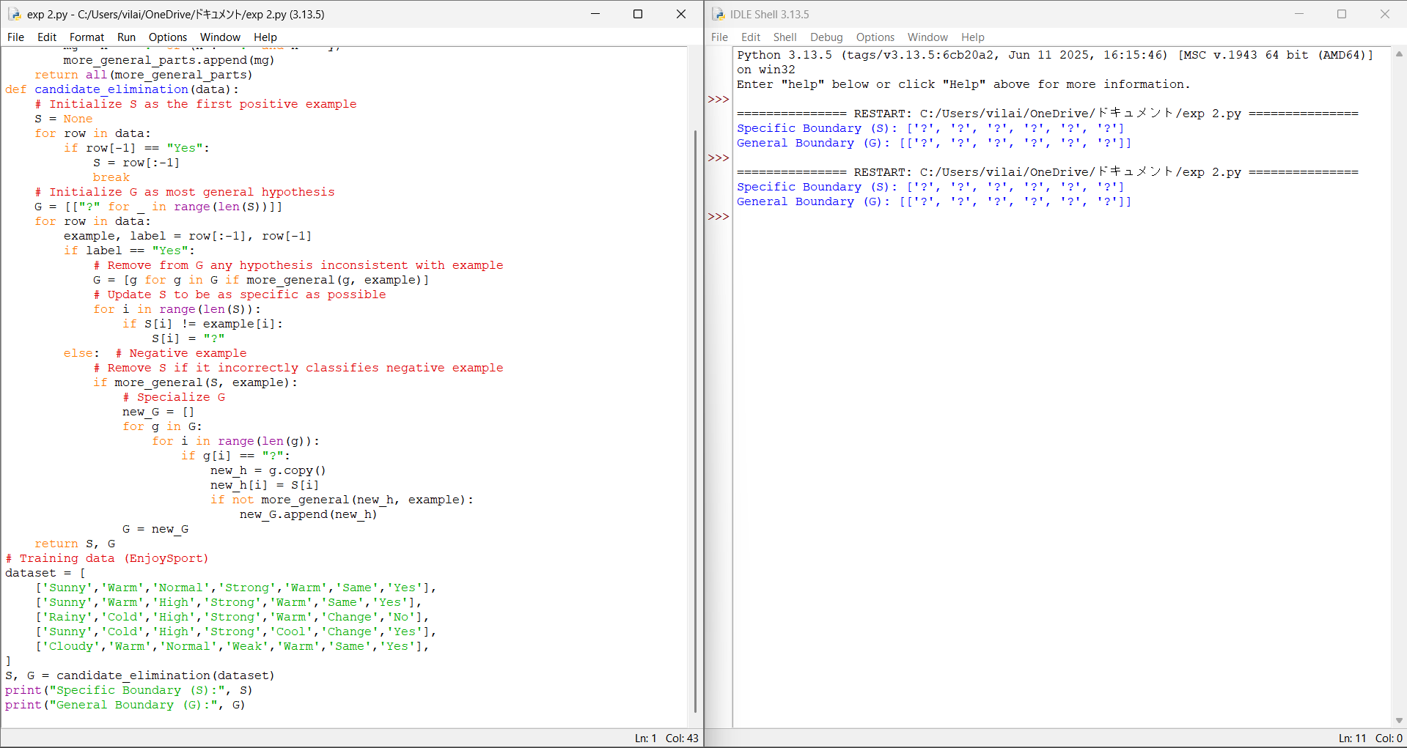

Experiment 3 : Demonstrate the working of the decision tree based ID3 algorithm. Use an appropriate data set for building the decision tree and apply this knowledge to classify a new sample.
import math
# Calculate entropy
def entropy(data):
labels = [row[-1] for row in data]
unique_labels = set(labels)
ent = 0
for label in unique_labels:
p = labels.count(label) / len(labels)
ent -= p * math.log2(p)
return ent
# Calculate Information Gain
def info_gain(data, col):
total_entropy = entropy(data)
values = set([row[col] for row in data])
weighted_entropy = 0
for v in values:
subset = [row for row in data if row[col] == v]
weighted_entropy += (len(subset) / len(data)) * entropy(subset)
return total_entropy - weighted_entropy
# ID3 Algorithm
def id3(data, features):
labels = [row[-1] for row in data]
# If all outputs are same → return that label
if labels.count(labels[0]) == len(labels):
return labels[0]
# If no features left
if not features:
return max(set(labels), key=labels.count)
# Find best attribute
gains = [info_gain(data, col) for col in features]
best_col = features[gains.index(max(gains))]
best_feature = "Feature_" + str(best_col)
tree = {best_feature: {}}
values = set(row[best_col] for row in data)
for v in values:
subset = [row for row in data if row[best_col] == v]
if not subset:
tree[best_feature][v] = max(set(labels), key=labels.count)
else:
new_features = [f for f in features if f != best_col]
tree[best_feature][v] = id3(subset, new_features)
return tree
# Sample dataset (Outlook, Temperature, Humidity, Wind, Play?)
dataset = [
['Sunny', 'Hot', 'High', 'Weak', 'No'],
['Sunny', 'Hot', 'High', 'Strong', 'No'],
['Overcast','Hot','High', 'Weak', 'Yes'],
['Rain', 'Mild', 'High', 'Weak', 'Yes'],
['Rain', 'Cool', 'Normal', 'Weak', 'Yes'],
['Rain', 'Cool', 'Normal', 'Strong', 'No'],
['Overcast','Cool','Normal','Strong','Yes'],
['Sunny', 'Mild', 'High', 'Weak', 'No'],
]
# Run ID3
features = [0, 1, 2, 3] # column indices
tree = id3(dataset, features)
print("Decision Tree:")
print(tree)
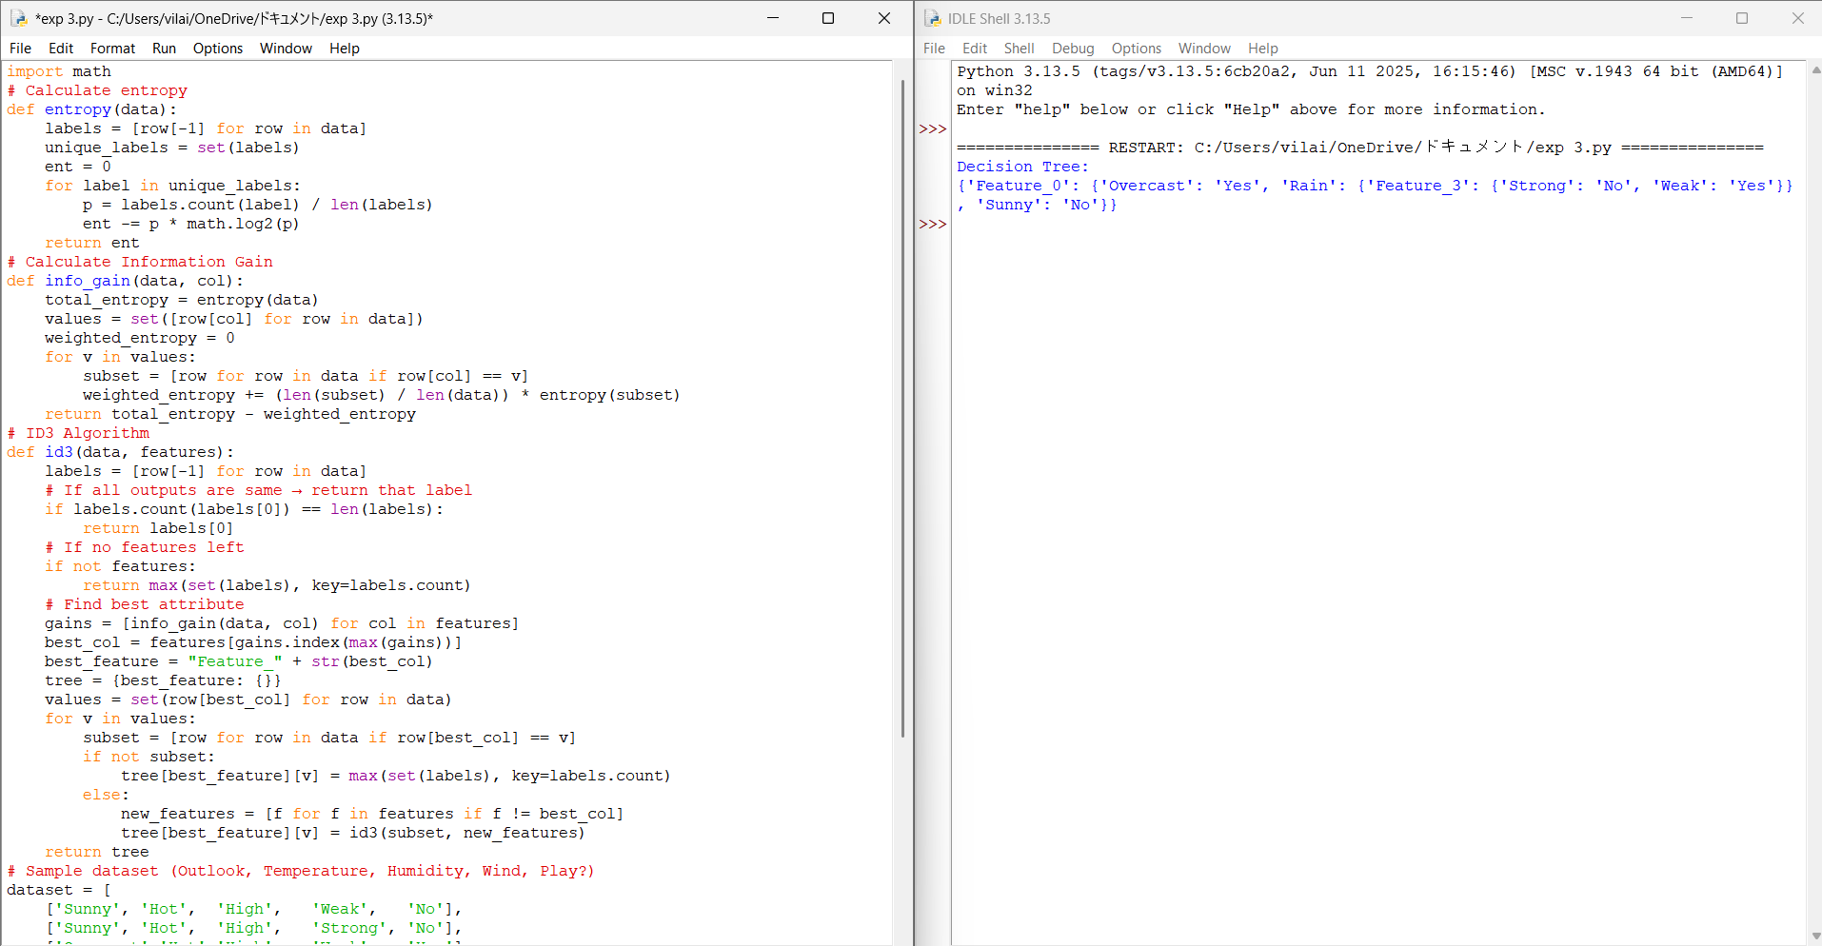
Experiment 4 : Build an Artificial Neural Network by implementing the Backpropagation algorithm and test the same using appropriate data sets.

# Perceptron Learning Algorithm for AND Gate
# Training data: [x1, x2, target]
training_data = [
[0, 0, 0],
[0, 1, 0],
[1, 0, 0],
[1, 1, 1]
]
# Initialize weights and bias
w1 = 0
w2 = 0
b = 0
lr = 1 # learning rate
# Activation function
def activation(x):
return 1 if x >= 0 else 0
# Training loop
for epoch in range(10):
print("Epoch:", epoch)
errors = 0
for x1, x2, target in training_data:
y = activation(w1*x1 + w2*x2 + b)
e = target - y
# Update rule
w1 = w1 + lr * e * x1
w2 = w2 + lr * e * x2
b = b + lr * e
errors += abs(e)
print(f"Input: {x1, x2}, Target: {target}, Output: {y}, Error: {e}")
if errors == 0:
print("Training complete!")
break
print("\nFinal Weights:")
print("w1 =", w1, ", w2 =", w2, ", bias =", b)
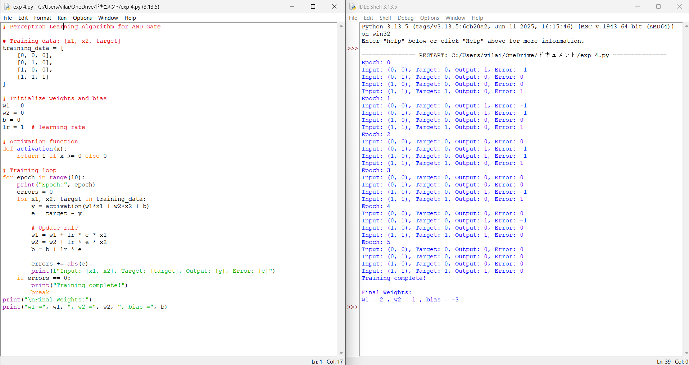

Experiment 5 : Write a program for Implementation of K-Nearest Neighbours (K-NN) in Python
# KNN Algorithm Implementation in Python
import math
# Calculate Euclidean Distance
def distance(p1, p2):
return math.sqrt(sum((a - b)**2 for a, b in zip(p1, p2)))
# KNN Function
def knn(training_data, test_point, k=3):
distances = []
for features, label in training_data:
dist = distance(features, test_point)
distances.append((dist, label))
# Sort by distance
distances.sort(key=lambda x: x[0])
# Get K nearest labels
k_neighbors = [label for _, label in distances[:k]]
# Majority vote
prediction = max(set(k_neighbors), key=k_neighbors.count)
return prediction
# Training dataset: ([features], label)
dataset = [
([2, 4], "A"),
([4, 6], "A"),
([4, 2], "A"),
([9, 10], "B"),
([10, 12], "B"),
([11, 9], "B")
]
test_sample = [5, 5]
pred = knn(dataset, test_sample, k=3)
print("Predicted Class:", pred)
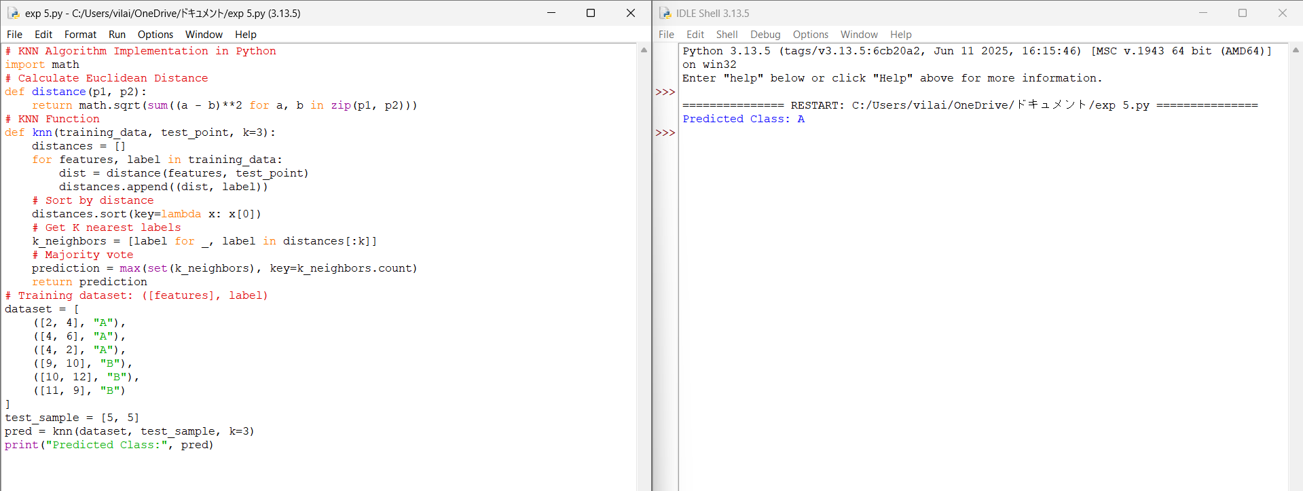

Experiment 6 : Write a program to implement Naïve Bayes algorithm in python and to display the results using confusion matrix and accuracy
# Naive Bayes Classifier (Categorical) - From Scratch
from collections import defaultdict
# Training dataset: [Outlook, Temperature, Humidity, Wind, Play]
dataset = [
['Sunny', 'Hot', 'High', 'Weak', 'No'],
['Sunny', 'Hot', 'High', 'Strong', 'No'],
['Overcast', 'Hot', 'High', 'Weak', 'Yes'],
['Rain', 'Mild', 'High', 'Weak', 'Yes'],
['Rain', 'Cool', 'Normal', 'Weak', 'Yes'],
['Rain', 'Cool', 'Normal', 'Strong', 'No'],
['Overcast', 'Cool', 'Normal', 'Strong', 'Yes'],
['Sunny', 'Mild', 'High', 'Weak', 'No']
]
# Separate features and labels
features = [row[:-1] for row in dataset]
labels = [row[-1] for row in dataset]
# Calculate prior probabilities
def prior_prob(labels):
priors = defaultdict(int)
for label in labels:
priors[label] += 1
total = len(labels)
for label in priors:
priors[label] /= total
return priors
# Calculate likelihoods
def likelihood(features, labels):
likelihoods = {}
for i in range(len(features[0])):
likelihoods[i] = {}
for feature_value, label in zip([row[i] for row in features], labels):
likelihoods[i].setdefault(label, defaultdict(int))
likelihoods[i][label][feature_value] += 1
# Convert counts to probabilities
for label in likelihoods[i]:
total = sum(likelihoods[i][label].values())
for value in likelihoods[i][label]:
likelihoods[i][label][value] /= total
return likelihoods
# Prediction function
def predict(test):
pp = {}
for label in priors:
pp[label] = priors[label]
for i in range(len(test)):
value = test[i]
if value in likelihoods[i][label]:
pp[label] *= likelihoods[i][label][value]
else:
pp[label] *= 0.0001 # smoothing
return max(pp, key=pp.get)
# Train Model
priors = prior_prob(labels)
likelihoods = likelihood(features, labels)
# Test sample
test_sample = ['Sunny','Cool','High','Strong']
prediction = predict(test_sample)
print("Test Sample:", test_sample)
print("Predicted Class:", prediction)

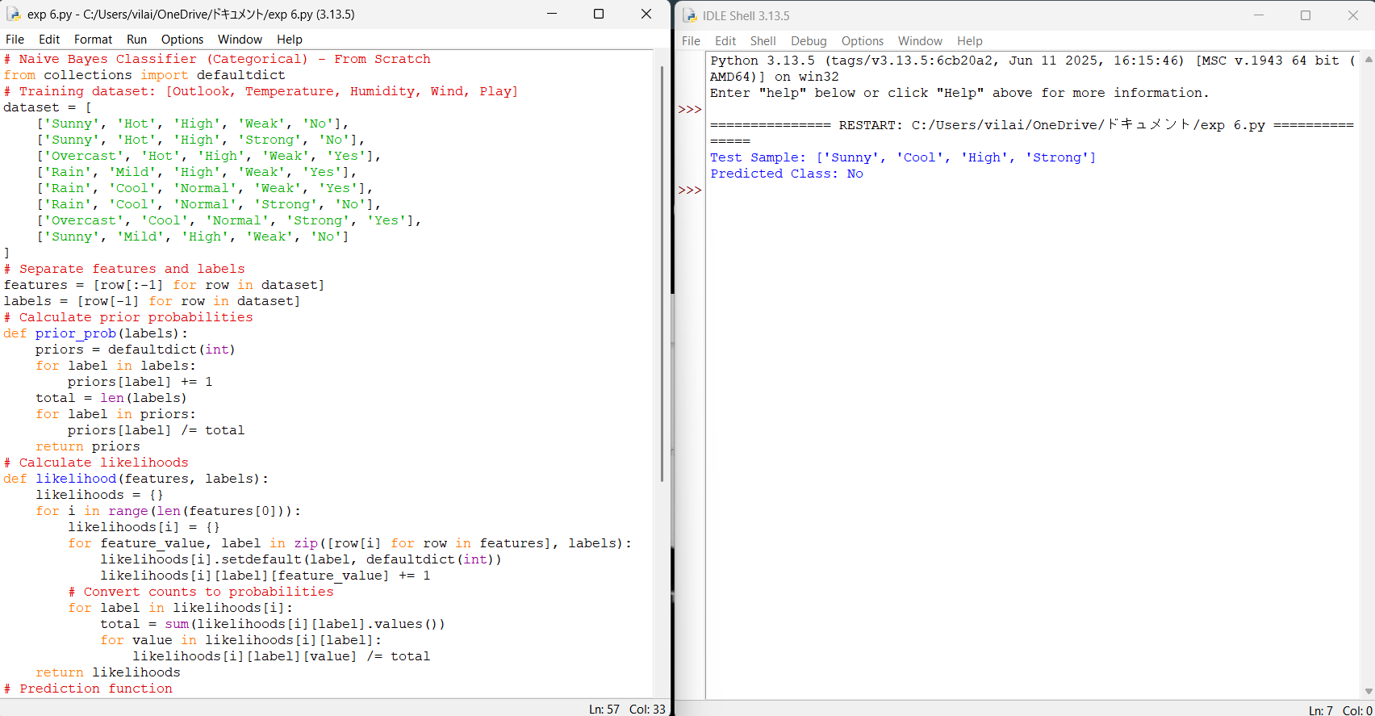

Experiment 7 : Write a program to implement Logistic Regression (LR) algorithm in python
# SVM Classifier using scikit-learn
from sklearn import svm
# Training data: [features], label
X = [
[2, 4],
[4, 6],
[4, 2],
[9, 10],
[10, 12],
[11, 9]
]
Y = ['A', 'A', 'A', 'B', 'B', 'B']

# Create SVM model (Linear Kernel)
model = svm.SVC(kernel='linear')
# Train the model
model.fit(X, Y)
# Test sample
test_point = [[5, 5]]
# Prediction
prediction = model.predict(test_point)
print("Test Point:", test_point)
print("Predicted Class:", prediction[0])
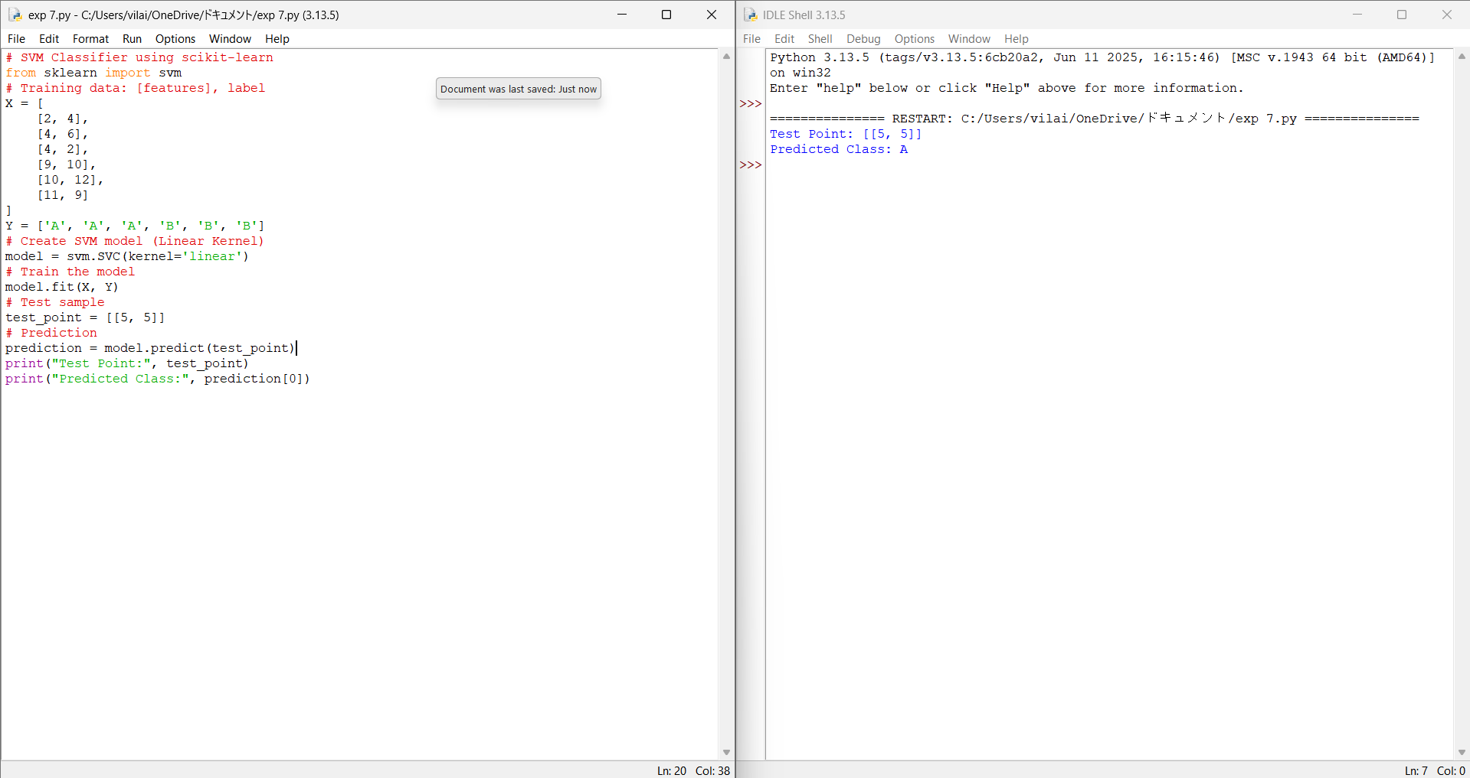

Experiment 8 – Write a program to implement Linear Regression (LR) algorithm in python
# Simple Linear Regression - Manual Implementation
# Sample Data (x: study hours, y: marks)
x = [1, 2, 3, 4, 5]
y = [2, 4, 5, 4, 5]
n = len(x)
# Calculate sums
sum_x = sum(x)
sum_y = sum(y)
sum_xy = sum([x[i]*y[i] for i in range(n)])
sum_x2 = sum([x[i]**2 for i in range(n)])
# Calculate slope (m) and intercept (c)
m = (n*sum_xy - sum_x*sum_y) / (n*sum_x2 - (sum_x**2))
c = (sum_y - m*sum_x) / n
print("Slope (m):", m)
print("Intercept (c):", c)
# Predict value for x = 6
x_test = 6
y_pred = m * x_test + c
print("Predicted value for x=6:", y_pred)

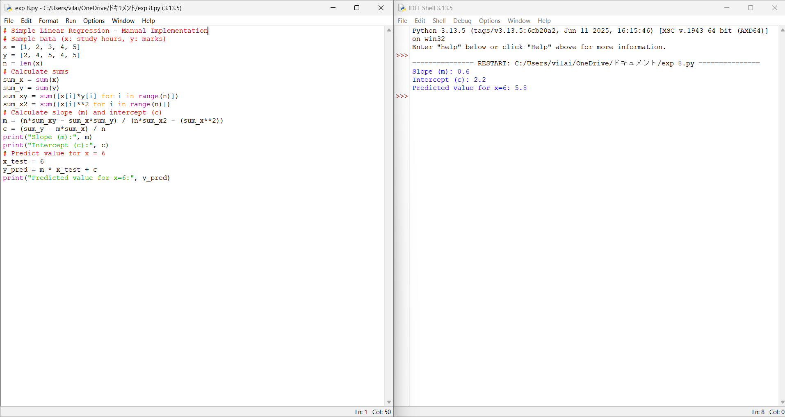

Experiment 9 - Compare Linear and Polynomial Regression using Python
# Logistic Regression - Manual Implementation
import math
# Sigmoid Function
def sigmoid(z):
return 1 / (1 + math.exp(-z))
# Training data (Hours studied, Pass/Fail)
data = [
[1, 0],
[2, 0],
[3, 0],
[4, 1],
[5, 1],
[6, 1]
]
# Initialize weights
w = 0
b = 0
lr = 0.1 # learning rate
# Training
for epoch in range(1000):
for x, y in data:
z = w*x + b
h = sigmoid(z)
error = y - h
# Update rule
w += lr * error * x
b += lr * error
# Prediction
def predict(x):
return 1 if sigmoid(w*x + b) >= 0.5 else 0
# Test sample
test = 4.5
print("Prediction for x =", test, "=>", predict(test))
print("Final Weight:", w)
print("Final Bias:", b)
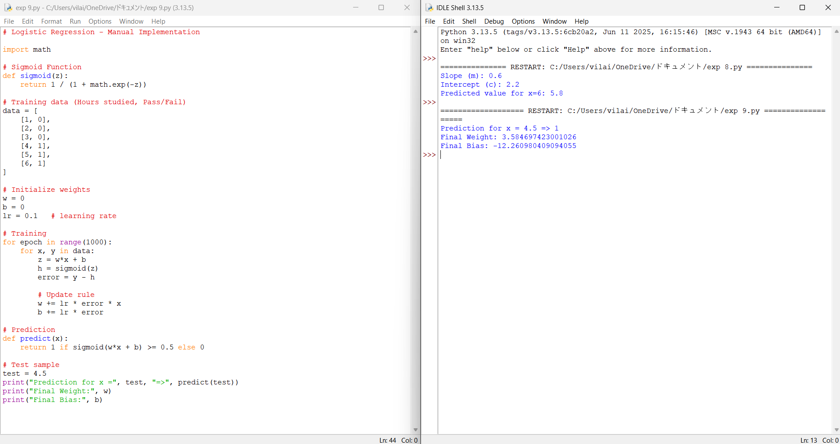

Experiment 10 – Write a Python Program to Implement Expectation & Maximization Algorithm
# K-Means Clustering - Manual Implementation
import random
import math
# Distance function
def distance(p1, p2):
return math.sqrt(sum((a - b) ** 2 for a, b in zip(p1, p2)))
# K-Means function
def kmeans(data, k, max_iter=10):
# Step 1: Initialize centroids randomly
centroids = random.sample(data, k)
for _ in range(max_iter):
clusters = [[] for _ in range(k)]
# Step 2: Assign points to nearest centroid
for point in data:
dists = [distance(point, c) for c in centroids]
cluster_index = dists.index(min(dists))
clusters[cluster_index].append(point)
# Step 3: Recalculate centroids
new_centroids = []
for cluster in clusters:
if cluster:
new_centroid = [sum(dim)/len(dim) for dim in zip(*cluster)]
new_centroids.append(new_centroid)
else:
new_centroids.append(random.choice(data))
# Check for convergence
if new_centroids == centroids:
break
centroids = new_centroids
return centroids, clusters
# Sample dataset (2D points)
dataset = [
[2, 5], [3, 4], [3, 6],
[8, 7], [9, 8], [10, 8]
]
k = 2
centroids, clusters = kmeans(dataset, k)
print("Final Centroids:", centroids)
print("Clusters:", clusters)

